**Process** is a structured set of **activities** designed to accomplish a specific **objective.** A process takes one or more defined inputs and turns them into defined outputs.

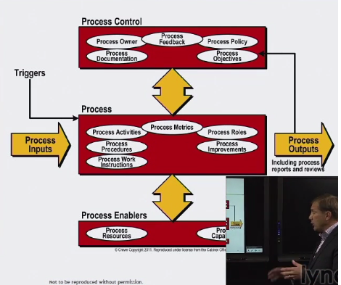

**Process owner –** ensuring process is as documented

**Enabler** – an ingredient – determine whether or not this process is going to exceed/resources or capabilities

**Process** – what

**Procedure** – who and how of the activity

**Close looped** – results of a process are typically provide for change or transformation of an event to a specific goal.

**Output** can go to a customer or another process

**Process characteristics**

**Measurable**

* Performance driven
* Managers measure cost, quality and other variables
* Practitioners measure duration productivity
* **Manage the performance of that process**

**Specific results**

* The reason a process exists is to deliver specific results
* Results must be individually identifiable and countable

**Customers**

* Processes have customers – internal or external
* Must meet customer expectations
* **Incident report services**
* **Have to meet their expectations**

**Responds to a specific event**

* Traceable to a specific trigger
* May be iterative or on going
* **A specific event kicks it off**

How to remember* MSCR – Mary sells customer rings

**PROCESSES, TOOLS, AND AUTOMATION**

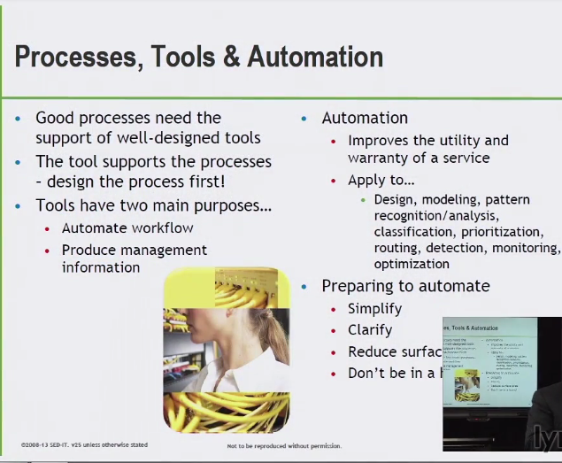

* REDUCE SURFACE AREA
* DON’T BE IN A HURRY

**Automate workflow –** reduce or remove human error/mechanical way to manage process

Measuring and improving processes

**Function –**

Unit of organization designed to do specific type of work

